Name: ​ ​ Date: ​
Year 12 Physics: Projectile Motion Problem Set
Question 1: Elevated Launch into the Ocean
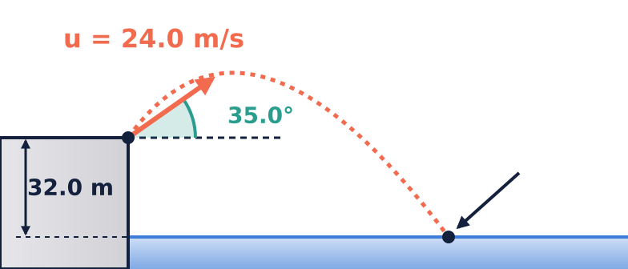
A coastal defense battery fires a test projectile from the edge of a cliff ​$32.0\text{ m}$​ above sea level. The projectile is launched with an initial speed of ​$24.0{\text{ m s}}^{−1}$​ at an angle of ​${35.0}^{∘}$​ above the horizontal.
(a) Determine the initial horizontal and vertical components of the launch velocity. (2 marks)
(b) Calculate the maximum height reached by the projectile above sea level. (2 marks)
(c) Calculate the total time of flight before the projectile strikes the water. (3 marks)
(d) Find the horizontal range from the base of the cliff to the impact site. (2 marks)
(e) Determine the magnitude and direction of the velocity vector immediately prior to impact with the water. (3 marks)
Question 2: Clearing an Obstacle
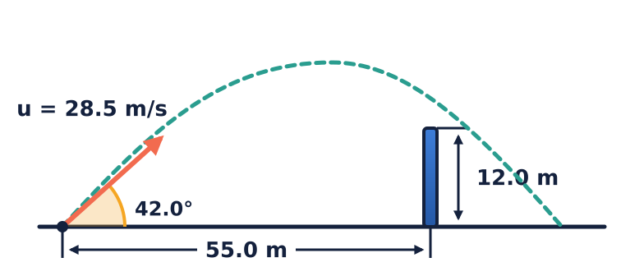
During a training simulation, a rugby ball is kicked from ground level with an initial velocity of ​$28.5{\text{ m s}}^{−1}$​ at an angle of ​${42.0}^{∘}$​ to the horizontal. A defensive training barrier of height ​$12.0\text{ m}$​ is positioned ​$55.0\text{ m}$​ horizontally downfield from the kick location.
(a) Show by calculation whether the ball clears the defensive barrier, and determine the vertical clearance margin. (4 marks)
(b) State whether the ball is ascending or descending as it passes over the barrier. Justify your answer with an explicit velocity calculation. (2 marks)
(c) Calculate the horizontal distance from the barrier to where the ball lands on the level ground. (3 marks)
Question 3: Horizontal Launch onto an Inclined Plane
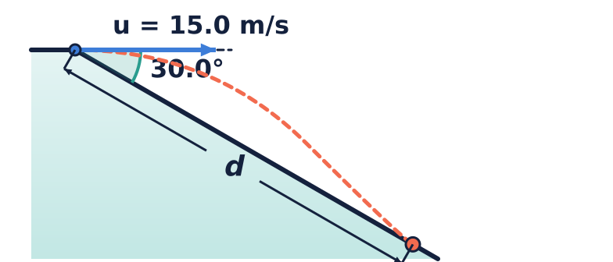
A rescue flare is fired horizontally at ​$15.0{\text{ m s}}^{−1}$​ from the edge of a uniform hillside that slopes downwards at a constant angle of ​${30.0}^{∘}$​ below the horizontal.
(a) Write parametric equations for the horizontal displacement ​$x(t)$​ and vertical displacement ​$y(t)$​ as functions of time ​$t$​, taking the launch point as the origin ​$(0,0)$​. (2 marks)
(b) By equating the trajectory to the geometry of the incline, calculate the time elapsed from launch until the flare strikes the slope. (3 marks)
(c) Calculate the straight-line distance along the slope from the launch point to the point of impact. (2 marks)
Question 4: Aeroplane Supply Drop
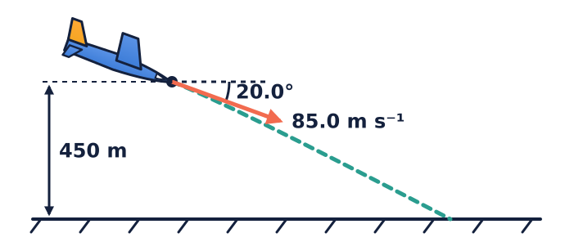
A humanitarian transport aeroplane is descending at a constant angle of ​${20.0}^{∘}$​ below the horizontal at a speed of ​$85.0{\text{ m s}}^{−1}$​. When the aeroplane is at an altitude of ​$450\text{ m}$​, an emergency supply container is released from the cargo bay.
(a) State the initial horizontal and vertical velocity components of the container at the instant of release. (2 marks)
(b) Calculate the total time taken for the container to strike the ground. (3 marks)
(c) Calculate the horizontal distance travelled by the container between release and ground impact. (2 marks)
(d) In real atmospheric conditions, the supply container experiences non-negligible air resistance. Explain qualitatively how air resistance would affect: (3 marks)
☐ The horizontal velocity throughout the descent.
☐ The total time of flight compared to the ideal theoretical value.
☐ The final angle of impact relative to the horizontal.
For Questions 5-24, take ​$g=9.80{\text{ m s}}^{−2}$​ and neglect air resistance unless otherwise stated. Take upwards as positive when resolving vertically.
Question 5: Two Launch Angles
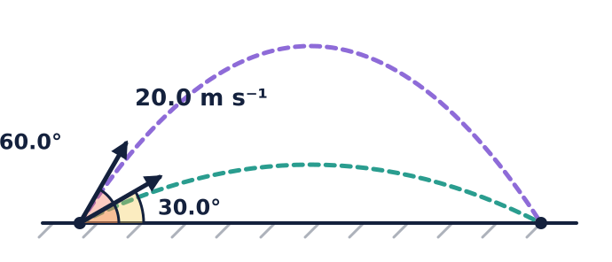
A ball is launched at ​$20.0{\text{ m s}}^{−1}$​ from level ground. Two possible launch angles are ​${30.0}^{∘}$​ and ​${60.0}^{∘}$​. The ball lands at its launch height.
(a) Calculate the time of flight and range for each angle. (4 marks) (b) Calculate the maximum height for each angle. (2 marks) (c) Explain why the ranges are equal but the flight times differ. (2 marks)
Question 6: Finding Launch Speed from Range and Angle
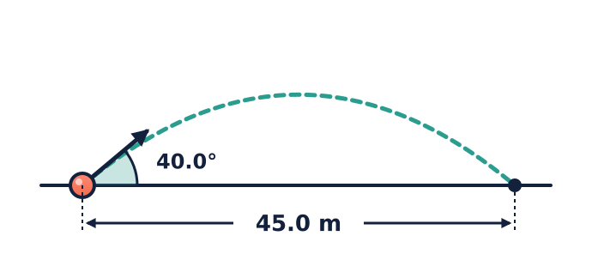
A ball is launched from level ground at ​${40.0}^{∘}$​ above the horizontal and lands at the same height, ​$45.0\text{ m}$​ away.
(a) Determine its launch speed. (3 marks) (b) Find its maximum height and total flight time. (3 marks) (c) Determine its velocity immediately before landing. (2 marks)
Question 7: Determining the Launch Components
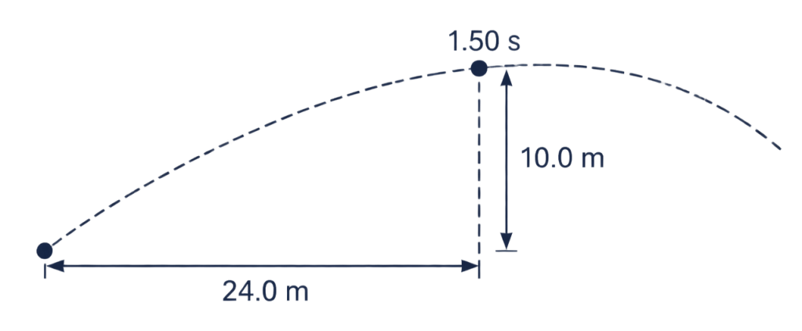
A projectile passes through a point ​$24.0\text{ m}$​ horizontally and ​$10.0\text{ m}$​ vertically above its launch point exactly ​$1.50\text{ s}$​ after launch.
(a) Determine the initial horizontal and vertical velocity components. (3 marks) (b) Find the launch speed and angle. (2 marks) (c) Find the projectile's maximum height above the launch point. (2 marks)
Question 8: Two Times at the Same Height
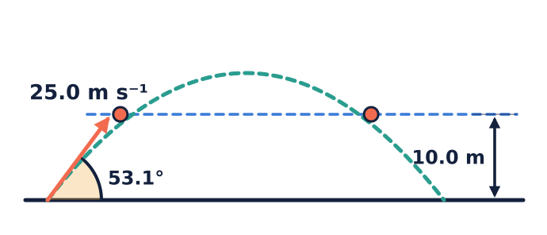
A ball is launched from level ground at ​$25.0{\text{ m s}}^{−1}$​ and ​${53.1}^{∘}$​ above the horizontal. A horizontal observation plane is ​$10.0\text{ m}$​ above the launch point.
(a) Find the two times at which the ball crosses the observation plane. (3 marks) (b) Find its horizontal position and vertical velocity at each crossing. (4 marks) (c) Explain the difference between the vertical velocities. (2 marks)
Question 9: Interception by a Moving Cart
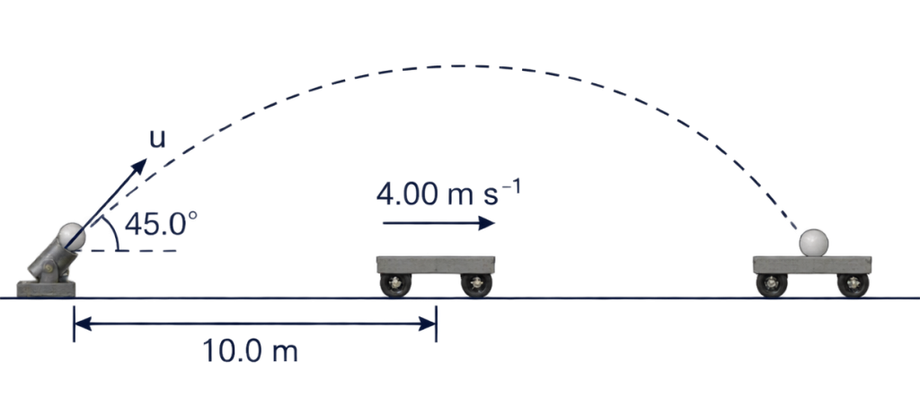
A cart travels at a constant ​$4.00{\text{ m s}}^{−1}$​ to the right on level ground. At the instant it is ​$10.0\text{ m}$​ to the right of a launcher, a ball is launched from ground level to the right at ​${45.0}^{∘}$​. The cart catches the ball at ground level.
(a) Write expressions for the horizontal positions of the ball and cart. (2 marks) (b) Calculate the required ball launch speed. (4 marks) (c) Find the interception time and position. (2 marks)
Question 10: Launch from a Moving Vehicle
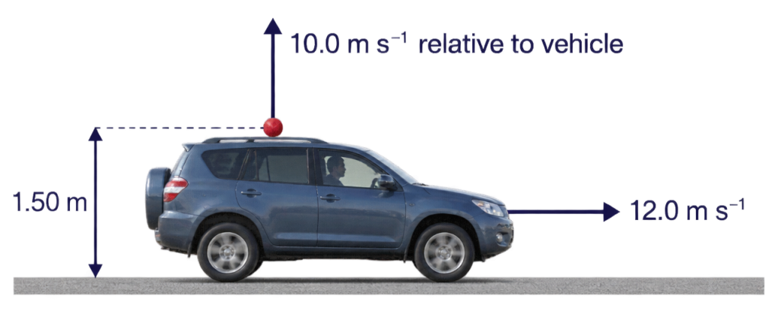
A vehicle moves horizontally at ​$12.0{\text{ m s}}^{−1}$​ to the right. A ball is thrown from it at ​$10.0{\text{ m s}}^{−1}$​ vertically upwards relative to the vehicle. The release point is ​$1.50\text{ m}$​ above level ground. The vehicle maintains its speed.
(a) State the ball's initial velocity components relative to the ground. (2 marks) (b) Find its time to reach the ground and horizontal displacement. (3 marks) (c) Describe its horizontal position relative to the vehicle throughout flight, assuming both continue unobstructed. (2 marks)
Question 11: Comparing Planetary Gravity
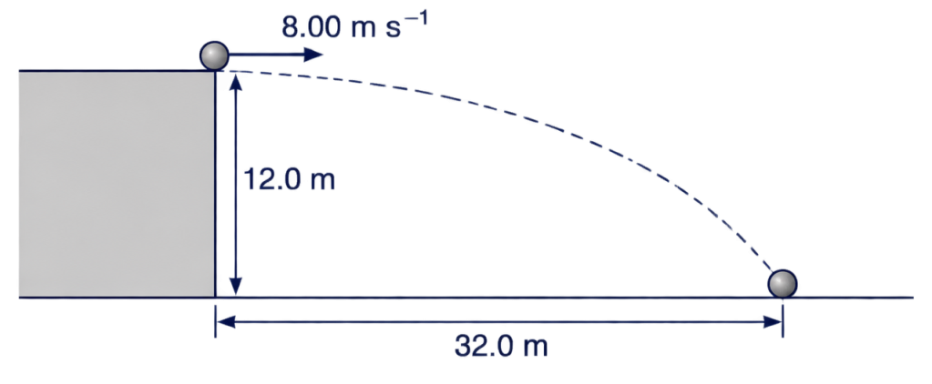
On a planet with negligible atmosphere, a ball launched horizontally at ​$8.00{\text{ m s}}^{−1}$​ from a height of ​$12.0\text{ m}$​ lands ​$32.0\text{ m}$​ from the point directly below launch.
(a) Calculate its flight time and the planet's gravitational field strength. (3 marks) (b) Find its impact speed and direction. (3 marks) (c) If the same ball is launched horizontally at twice the speed from the same height, calculate its new range. (2 marks)
Question 12: Launch from a Platform to a Higher Target
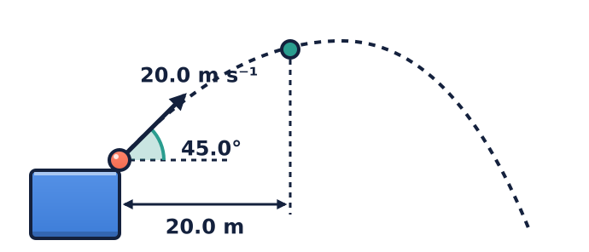
A ball is launched from a platform at ​$20.0{\text{ m s}}^{−1}$​ and ​${45.0}^{∘}$​ above the horizontal. A small target is ​$20.0\text{ m}$​ horizontally from the launch point.
(a) Calculate the ball's height above launch when it reaches the target's horizontal position. (3 marks) (b) Find its velocity there. (3 marks) (c) Determine whether it reaches that point before or after its maximum height. (1 mark)
Question 13: Minimum Speed to Reach a Target
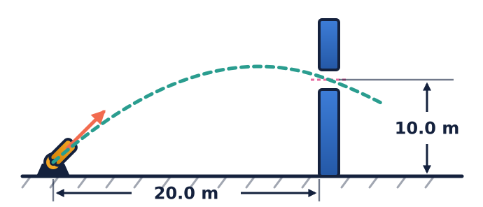
A launcher must send a ball from level ground through a small opening ​$20.0\text{ m}$​ horizontally away and ​$10.0\text{ m}$​ above launch. The ball must pass through the opening without first hitting the ground.
(a) Show that the squared launch speed can be written as ​$u^{2}=\frac{gx^{2}(1+\tan^{2}θ)}{2(xtanθ−y)}$​. (3 marks) (b) Determine the minimum launch speed and its angle. (4 marks) (c) Find the time to reach the opening for that launch. (2 marks)
Question 14: Two Angles for One Target
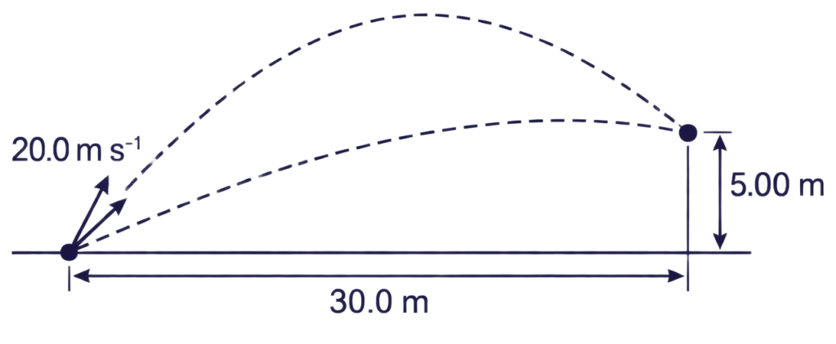
A ball is launched at ​$20.0{\text{ m s}}^{−1}$​ from level ground. It must pass through a point ​$30.0\text{ m}$​ horizontally away and ​$5.00\text{ m}$​ above launch.
(a) Derive a quadratic equation in ​$tanθ$​ for the possible launch angles. (3 marks) (b) Calculate both angles. (3 marks) (c) Calculate the time taken to reach the point for each angle. (2 marks)
Question 15: Reconstructing a Horizontal Launch
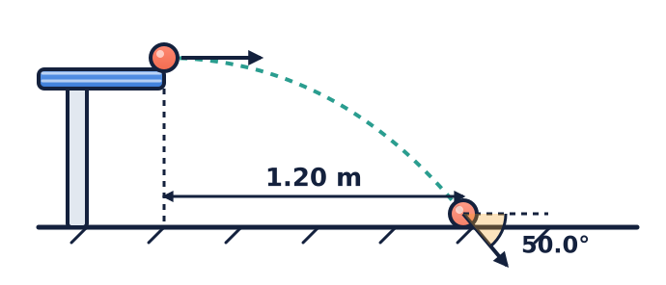
A ball rolls horizontally off a table and lands on level ground ​$1.20\text{ m}$​ from the table edge. Its impact velocity is at ​${50.0}^{∘}$​ below the horizontal.
(a) Determine the time of flight and horizontal launch speed. (4 marks) (b) Find the table height. (2 marks) (c) Calculate the ball's impact speed. (2 marks)
Question 16: Projectile Energy
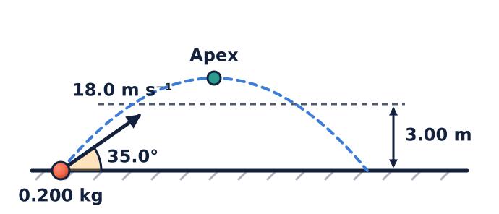
A ​$0.200\text{ kg}$​ ball is launched at ​$18.0{\text{ m s}}^{−1}$​ and ​${35.0}^{∘}$​ above the horizontal from level ground.
(a) Find its initial kinetic energy. (2 marks) (b) Calculate its maximum height and kinetic energy at that point. (3 marks) (c) Use energy conservation to find its speed when it is ​$3.00\text{ m}$​ above launch, and explain why it can have this speed at two different times. (3 marks)
Question 17: Vertical Velocity from a Measured Apex
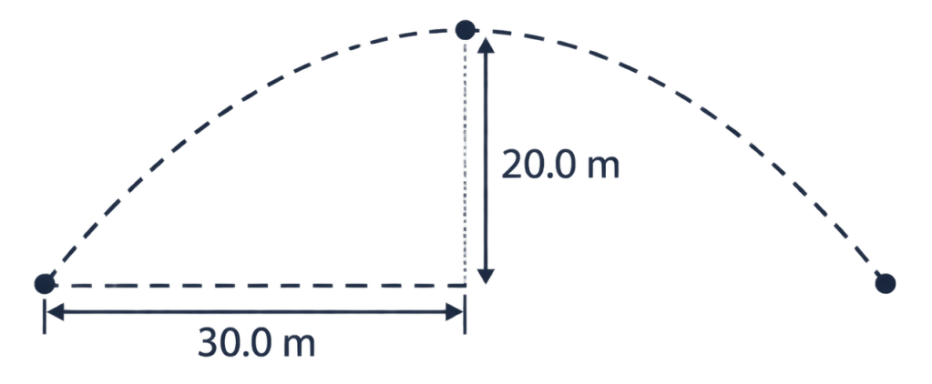
A projectile reaches a maximum height of ​$20.0\text{ m}$​ above its launch point and is horizontally displaced ​$30.0\text{ m}$​ when it reaches that maximum.
(a) Determine the initial vertical and horizontal velocity components. (3 marks) (b) Find the launch speed and angle. (2 marks) (c) Calculate the range if it lands at its launch height. (2 marks)
Question 18: Finding Gravity from Stroboscopic Data
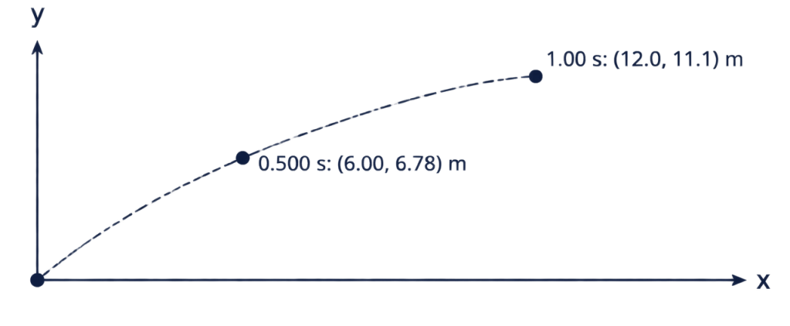
A projectile is photographed at equal intervals of ​$0.500\text{ s}$​. Relative to the launch point, its coordinates are ​$(6.00,6.78)\text{ m}$​ at ​$0.500\text{ s}$​ and ​$(12.0,11.1)\text{ m}$​ at ​$1.00\text{ s}$​. The coordinates are rounded to three significant figures. Estimate ​$g$​ from these measurements rather than assuming the stated value.
(a) Estimate the horizontal and initial vertical velocity components and gravitational acceleration from the data. (4 marks) (b) Predict the position at ​$1.50\text{ s}$​. (2 marks) (c) Explain one limitation of estimating acceleration from rounded measurements. (2 marks)
Question 19: Ball Thrown Downwards
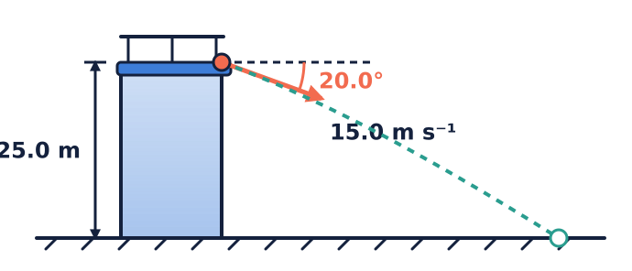
From a balcony ​$25.0\text{ m}$​ above level ground, a ball is thrown at ​$15.0{\text{ m s}}^{−1}$​ at ​${20.0}^{∘}$​ below the horizontal.
(a) Find the time to reach the ground and horizontal displacement. (3 marks) (b) Determine the impact speed and angle. (3 marks) (c) Compare its impact speed with that of a ball thrown horizontally at the same speed from the same height, neglecting air resistance. (2 marks)
Question 20: Maximum Range from a Fixed Speed
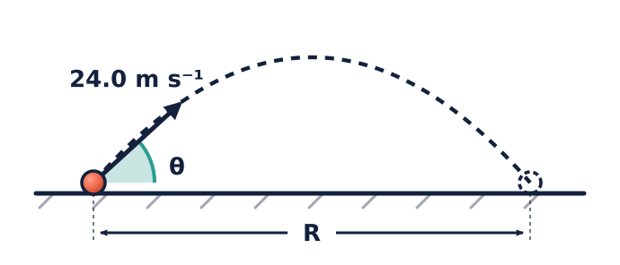
A ball is launched at a fixed speed of ​$24.0{\text{ m s}}^{−1}$​ and lands at its launch height on level ground.
(a) Derive the range in terms of launch speed, angle and ​$g$​. (3 marks) (b) Determine the angle and maximum range. (2 marks) (c) Determine the two angles that give a range of ​$40.0\text{ m}$​. (3 marks)
Question 21: A Moving Catcher
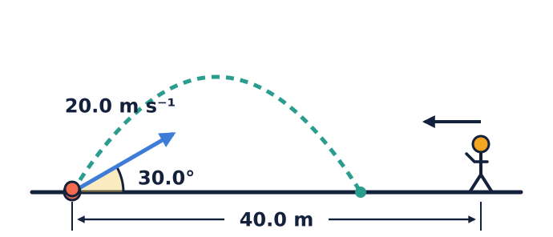
A ball is launched from ground level at ​$20.0{\text{ m s}}^{−1}$​ and ​${30.0}^{∘}$​ above the horizontal. At the same instant, a catcher starts ​$40.0\text{ m}$​ to the right of the launch point and runs left at constant speed. The catcher meets the ball at ground level.
(a) Calculate the ball's flight time and landing position. (3 marks) (b) Determine the catcher's required running speed. (2 marks) (c) Find the separation between catcher and ball at the instant the ball reaches its maximum height. (3 marks)
Question 22: Comparing Horizontal Launches
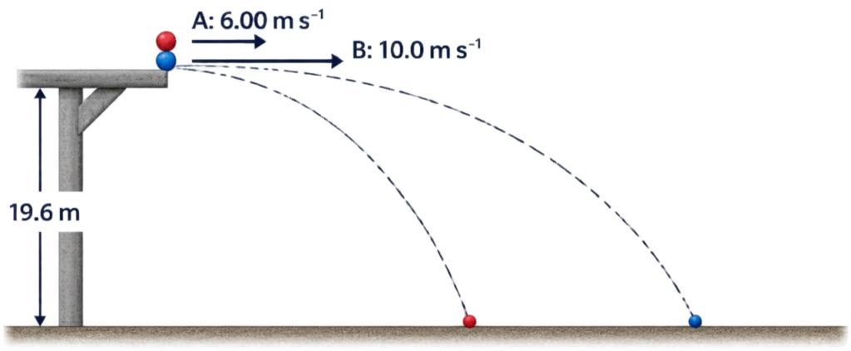
Two balls leave the same horizontal platform simultaneously. Ball A travels horizontally at ​$6.00{\text{ m s}}^{−1}$​ and ball B at ​$10.0{\text{ m s}}^{−1}$​ in the same direction. The platform is ​$19.6\text{ m}$​ above level ground.
(a) Calculate their common flight time and each range. (3 marks) (b) Find their separation after ​$1.00\text{ s}$​ and at landing. (2 marks) (c) Compare their impact speeds and vertical velocity components. (3 marks)
Question 23: Relative Motion of Two Balls
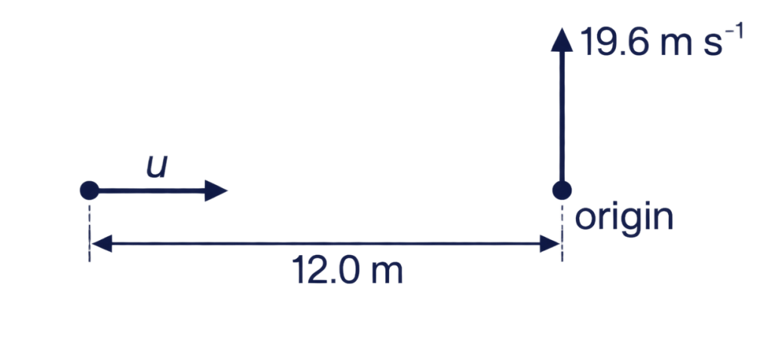
Two balls are launched simultaneously from points at the same height, well above any ground or obstruction. One ball is launched vertically upwards at ​$19.6{\text{ m s}}^{−1}$​ from the origin. The second is launched horizontally to the right from a point ​$12.0\text{ m}$​ to the left of the origin.
(a) Determine the horizontal speed needed for the second ball to be directly below or above the first after ​$1.50\text{ s}$​. (2 marks) (b) Calculate each ball's vertical position at that instant and their vertical separation. (3 marks) (c) Explain why changing the horizontal speed cannot make them collide after launch. (2 marks)
Question 24: Experimental Uncertainty in Range
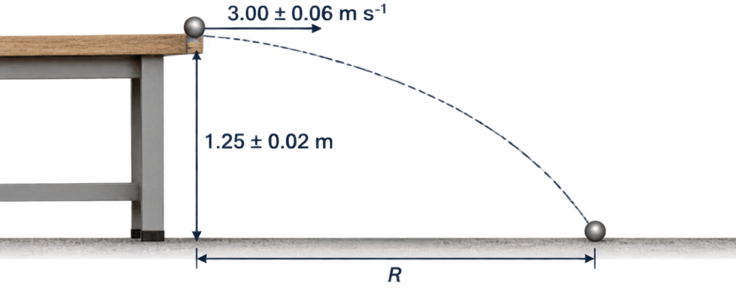
A ball is launched horizontally from a bench. The measured height is ​$1.25±0.02\text{ m}$​ and its horizontal speed is ​$3.00±0.06{\text{ m s}}^{−1}$​. Treat the stated uncertainties as small maximum absolute uncertainties.
(a) Calculate the predicted flight time and horizontal range. (3 marks) (b) Using ​$R=u\sqrt{2h/g}$​, estimate the maximum percentage uncertainty in the range. (3 marks) (c) Report the range with its absolute uncertainty and identify which measurement contributes more to its percentage uncertainty. (2 marks)

Answers
Question 1 Solutions
(a) Initial velocity components:
​$u_{x}=ucosθ=24.0cos({35.0}^{∘})=19.66≈19.7{\text{ m s}}^{−1}$​
​$u_{y}=usinθ=24.0sin({35.0}^{∘})=13.77≈13.8{\text{ m s}}^{−1}$​ (upwards)
(b) Maximum vertical displacement above launch:
At maximum height, ​$v_{y}=0$​:
​$v_{y}^{2}=u_{y}^{2}−2gΔy_{\text{peak}} ⟹ Δy_{\text{peak}}=\frac{u_{y}^{2}}{2g}=\frac{(13.766)^{2}}{2×9.80}=\frac{189.50}{19.60}=9.67\text{ m}$​
Total height above sea level: ​$h_{max}^{}=32.0+9.67=41.7\text{ m}$​
(c) Time of flight:
Taking upwards as positive, vertical displacement at sea level is ​$s_{y}=−32.0\text{ m}$​:
​$s_{y}=u_{y}t−\frac{1}{2}gt^{2} ⟹ −32.0=13.766t−4.90t^{2}$​
Rearranging into standard quadratic form: ​$4.90t^{2}−13.766t−32.0=0$​
​$t=\frac{13.766±\sqrt{(−13.766)^{2}−4(4.90)(−32.0)}}{2×4.90}=\frac{13.766±\sqrt{189.50+627.20}}{9.80}=\frac{13.766+28.578}{9.80}≈4.32\text{ s}$​
(d) Horizontal range:
​$s_{x}=u_{x}×t=19.66×4.321=84.95≈85.0\text{ m}$​
(e) Impact velocity vector:
Horizontal component remains constant: ​$v_{x}=u_{x}=19.66{\text{ m s}}^{−1}$​
Vertical component at impact: ​$v_{y}=u_{y}−gt=13.766−(9.80×4.321)=−28.58{\text{ m s}}^{−1}$​
Magnitude: ​$v=\sqrt{v_{x}^{2}+v_{y}^{2}}=\sqrt{(19.66)^{2}+(−28.58)^{2}}=\sqrt{386.5+816.8}=34.7{\text{ m s}}^{−1}$​
Direction: ​$θ=\tan^{−1}\left(\frac{∣v_{y}∣}{v_{x}}\right)=\tan^{−1}\left(\frac{28.58}{19.66}\right)={55.5}^{∘}$​ below the horizontal.
Final velocity: ​$34.7{\text{ m s}}^{−1}$​ at ​${55.5}^{∘}$​ below the horizontal.
Question 2 Solutions
(a) Initial velocity components:
​$u_{x}=28.5cos({42.0}^{∘})=21.18{\text{ m s}}^{−1}$​
​$u_{y}=28.5sin({42.0}^{∘})=19.07{\text{ m s}}^{−1}$​
Time taken to travel ​$55.0\text{ m}$​ horizontally:
​$t=\frac{s_{x}}{u_{x}}=\frac{55.0}{21.18}=2.597\text{ s}$​
Vertical position at ​$t=2.597\text{ s}$​:
​$s_{y}=u_{y}t−\frac{1}{2}gt^{2}=(19.07×2.597)−(0.5×9.80×{2.597}^{2})=49.52−33.05=16.47\text{ m}$​
Clearance margin above ​$12.0\text{ m}$​ barrier: ​$16.47−12.00=4.47\text{ m}$​. The ball clears the barrier by ​$4.47\text{ m}$​.
(b) Vertical velocity at the instant it passes the barrier:
​$v_{y}=u_{y}−gt=19.07−(9.80×2.597)=19.07−25.45=−6.38{\text{ m s}}^{−1}$​
Because ​$v_{y}<0$​, the vertical velocity is directed downwards; therefore, the ball is descending as it passes over the barrier.
(c) Total flight time to reach ground level (​$s_{y}=0$​):
​$t_{\text{total}}=\frac{2u_{y}}{g}=\frac{2×19.07}{9.80}=3.892\text{ s}$​
Total horizontal range: ​$R=u_{x}×t_{\text{total}}=21.18×3.892=82.43\text{ m}$​
Distance beyond the barrier: ​$82.43−55.00=27.4\text{ m}$​
Question 3 Solutions
(a) Parametric equations:
Horizontal displacement: ​$x(t)=ut=15.0t$​
Vertical displacement (taking downwards as positive): ​$y(t)=\frac{1}{2}gt^{2}=4.90t^{2}$​
(b) Geometry of the slope:
For a slope inclined at ​${30.0}^{∘}$​ below the horizontal:
​$tan({30.0}^{∘})=\frac{y}{x} ⟹ y=xtan({30.0}^{∘})=0.5774x$​
Substitute the parametric relations:
​$4.90t^{2}=0.5774(15.0t) ⟹ 4.90t^{2}=8.660t$​
Since ​$t≠0$​: ​$t=\frac{8.660}{4.90}≈1.77\text{ s}$​
(c) Distance along the slope:
​$x=15.0×1.767=26.51\text{ m}$​
Distance along incline ​$d=\frac{x}{cos({30.0}^{∘})}=\frac{26.51}{cos({30.0}^{∘})}=\frac{26.51}{0.8660}=30.6\text{ m}$​
Question 4 Solutions
(a) Initial velocity components (taking downwards as negative):
​$u_{x}=85.0cos({20.0}^{∘})=79.87≈79.9{\text{ m s}}^{−1}$​
​$u_{y}=−85.0sin({20.0}^{∘})=−29.07≈−29.1{\text{ m s}}^{−1}$​ (downwards)
(b) Time to reach the ground (​$s_{y}=−450\text{ m}$​):
​$s_{y}=u_{y}t−\frac{1}{2}gt^{2} ⟹ −450=−29.07t−4.90t^{2}$​
​$4.90t^{2}+29.07t−450=0$​
​$t=\frac{−29.07±\sqrt{(29.07)^{2}−4(4.90)(−450)}}{2×4.90}=\frac{−29.07+\sqrt{845.1+8820}}{9.80}=\frac{−29.07+98.31}{9.80}≈7.07\text{ s}$​
(c) Horizontal displacement:
​$s_{x}=u_{x}×t=79.87×7.065=564\text{ m}$​
(d) Qualitative effects of air resistance:
• Horizontal velocity: Opposing drag continually reduces ​$v_{x}$​, causing it to decay throughout flight rather than remain constant.
• Time of flight: Because the container is already moving downwards rapidly (​$u_{y}=−29.1{\text{ m s}}^{−1}$​), drag acts upwards against the downward motion, reducing the downward acceleration below ​$9.80{\text{ m s}}^{−2}$​. This increases the total time taken to descend ​$450\text{ m}$​.
• Impact angle: Because ​$v_{x}$​ is substantially reduced by drag while vertical descent velocity approaches terminal speed, the ratio ​$\frac{∣v_{y}∣}{v_{x}}$​ increases, resulting in a steeper impact angle (closer to ​${90}^{∘}$​ relative to horizontal).
Question 5 Solutions
(a) ​$T=2usinθ/g$​ and ​$R=u^{2}sin(2θ)/g$​. At ​${30.0}^{∘}$​, ​$T=2.04\text{ s}$​ and ​$R=35.3\text{ m}$​. At ​${60.0}^{∘}$​, ​$T=3.53\text{ s}$​ and ​$R=35.3\text{ m}$​.
(b) ​$H=u^{2}\sin^{2}θ/(2g)$​ gives ​$5.10\text{ m}$​ and ​$15.3\text{ m}$​ respectively. (c) Complementary angles have the same ​$sin(2θ)$​, but their vertical components differ, so their flight times differ.
Question 6 Solutions
(a) ​$u=\sqrt{Rg/sin(2θ)}=\sqrt{45.0(9.80)/sin{80.0}^{∘}}=21.2{\text{ m s}}^{−1}$​.
(b) ​$u_{y}=21.16sin{40.0}^{∘}=13.60{\text{ m s}}^{−1}$​. Thus ​$H=u_{y}^{2}/(2g)=9.43\text{ m}$​ and ​$T=2u_{y}/g=2.78\text{ s}$​. (c) The impact velocity is ​$21.2{\text{ m s}}^{−1}$​ at ​${40.0}^{∘}$​ below horizontal, with components ​$16.2{\text{ m s}}^{−1}$​ and ​$−13.6{\text{ m s}}^{−1}$​.
Question 7 Solutions
(a) ​$u_{x}=24.0/1.50=16.0{\text{ m s}}^{−1}$​; ​$u_{y}=(10.0+4.90(1.50)^{2})/1.50=14.0{\text{ m s}}^{−1}$​.
(b) ​$u=\sqrt{{16.0}^{2}+{14.02}^{2}}=21.3{\text{ m s}}^{−1}$​ and ​$θ=\tan^{−1}(14.02/16.0)={41.2}^{∘}$​. (c) ​$H={14.02}^{2}/(19.6)=10.0\text{ m}$​.
Question 8 Solutions
(a) ​$u_{x}=25.0cos{53.1}^{∘}=15.0{\text{ m s}}^{−1}$​, ​$u_{y}=25.0sin{53.1}^{∘}=20.0{\text{ m s}}^{−1}$​. Solve ​$10.0=u_{y}t−4.90t^{2}$​: ​$t=0.584\text{ s}$​ or ​$3.50\text{ s}$​.
(b) ​$x=u_{x}t$​ gives ​$8.77\text{ m}$​ and ​$52.5\text{ m}$​; ​$v_{y}=u_{y}−9.80t$​ gives ​$+14.3{\text{ m s}}^{−1}$​ and ​$−14.3{\text{ m s}}^{−1}$​. (c) At the same height the vertical speed is equal, but its direction reverses between ascent and descent.
Question 9 Solutions
(a) ​$x_{\text{ball}}=ucos{45}^{∘}t$​, ​$x_{\text{cart}}=10.0+4.00t$​. (b) Set ​$w=u/\sqrt{2}$​. At ground level ​$t=2w/9.80$​, so ​$w(2w/9.80)=10+4(2w/9.80)$​. Hence ​$w^{2}−4w−49=0$​, ​$w=9.28{\text{ m s}}^{−1}$​ and ​$u=13.1{\text{ m s}}^{−1}$​.
(c) ​$t=2(9.28)/9.80=1.89\text{ s}$​; ​$x=10+4t=17.6\text{ m}$​.
Question 10 Solutions
(a) Ground-frame components are ​$u_{x}=12.0{\text{ m s}}^{−1}$​ and ​$u_{y}=10.0{\text{ m s}}^{−1}$​. (b) Solve ​$−1.50=10.0t−4.90t^{2}$​ to obtain ​$t=2.18\text{ s}$​ and ​$x=12.0t=26.2\text{ m}$​. (c) The ball and vehicle have the same constant horizontal velocity, so the ball stays horizontally above the release position on the vehicle.
Question 11 Solutions
(a) ​$t=32.0/8.00=4.00\text{ s}$​ and ​$g=2h/t^{2}=2(12.0)/{4.00}^{2}=1.50{\text{ m s}}^{−2}$​. (b) ​$v_{x}=8.00$​, ​$v_{y}=−1.50(4.00)=−6.00{\text{ m s}}^{−1}$​. Speed ​$=10.0{\text{ m s}}^{−1}$​ and angle ​$=\tan^{−1}(6/8)={36.9}^{∘}$​ below horizontal. (c) Flight time is unchanged, so ​$R=16.0(4.00)=64.0\text{ m}$​.
Question 12 Solutions
(a) ​$u_{x}=u_{y}=20/\sqrt{2}=14.14{\text{ m s}}^{−1}$​, so ​$t=20.0/14.14=1.414\text{ s}$​ and ​$y=14.14(1.414)−4.90(1.414)^{2}=10.2\text{ m}$​. (b) ​$v_{y}=14.14−9.80(1.414)=0.283{\text{ m s}}^{−1}$​; velocity is ​$14.1{\text{ m s}}^{−1}$​ at ​${1.15}^{∘}$​ above horizontal. (c) It is still ascending, so the point is reached before the maximum.
Question 13 Solutions
(a) Substitute ​$t=x/(ucosθ)$​ in ​$y=usinθt−gt^{2}/2$​, then use ​$1/\cos^{2}θ=1+\tan^{2}θ$​ and rearrange to obtain the stated expression.
(b) Put ​$p=tanθ$​ and minimise ​$(1+p^{2})/(20p−10)$​ for ​$p>0.5$​. Setting its derivative to zero gives ​$p^{2}−p−1=0$​, so ​$p=(1+\sqrt{5})/2=1.618$​ and ​$θ={58.3}^{∘}$​. Substitution gives ​$u_{min}^{}=\sqrt{9.80(10.0+\sqrt{{20.0}^{2}+{10.0}^{2}})}=17.8{\text{ m s}}^{−1}$​. The expression diverges at both ends of the allowed interval, so this stationary value is the minimum.
(c) ​$t=20.0/(17.81cos{58.3}^{∘})=2.14\text{ s}$​.
Question 14 Solutions
(a) With ​$p=tanθ$​, ​$5.00=30.0p−\frac{9.80(30.0)^{2}}{2(20.0)^{2}}(1+p^{2})$​, giving ​$11.025p^{2}−30.0p+16.025=0$​.
(b) The roots are ​$p=0.730$​ and ​$1.99$​, so ​$θ={36.1}^{∘}$​ or ​${63.4}^{∘}$​. (c) ​$t=30.0/(20.0cosθ)$​ gives ​$1.86\text{ s}$​ or ​$3.34\text{ s}$​ respectively.
Question 15 Solutions
(a) With ​$u_{x}=1.20/t$​ and ​$∣v_{y}∣=9.80t$​, ​$tan{50.0}^{∘}=9.80t^{2}/1.20$​. Thus ​$t=0.382\text{ s}$​ and ​$u_{x}=3.14{\text{ m s}}^{−1}$​. (b) ​$h=4.90t^{2}=0.715\text{ m}$​. (c) ​$v=u_{x}/cos{50.0}^{∘}=4.89{\text{ m s}}^{−1}$​.
Question 16 Solutions
(a) ​$E_{k}=\frac{1}{2}(0.200)(18.0)^{2}=32.4\text{ J}$​. (b) ​$u_{y}=18sin{35}^{∘}=10.32{\text{ m s}}^{−1}$​; ​$H=u_{y}^{2}/(2g)=5.44\text{ m}$​. At the peak ​$v_{x}=18cos{35}^{∘}=14.74{\text{ m s}}^{−1}$​, so ​$E_{k}=\frac{1}{2}(0.200)(14.74)^{2}=21.7\text{ J}$​.
(c) ​$v^{2}=u^{2}−2gh={18.0}^{2}−2(9.80)(3.00)=265.2$​, so ​$v=16.3{\text{ m s}}^{−1}$​. The ball crosses this height once ascending and once descending; the velocity directions differ but the speeds are equal.
Question 17 Solutions
(a) ​$u_{y}=\sqrt{2gH}=\sqrt{2(9.80)(20.0)}=19.8{\text{ m s}}^{−1}$​. The time to the apex is ​$19.8/9.80=2.02\text{ s}$​, so ​$u_{x}=30.0/2.02=14.8{\text{ m s}}^{−1}$​. (b) ​$u=\sqrt{{19.8}^{2}+{14.85}^{2}}=24.7{\text{ m s}}^{−1}$​, ​$θ=\tan^{−1}(19.8/14.85)={53.1}^{∘}$​. (c) Symmetry gives ​$R=2(30.0)=60.0\text{ m}$​.
Question 18 Solutions
(a) ​$u_{x}=6.00/0.500=12.0{\text{ m s}}^{−1}$​. The vertical observations give ​$6.78=0.500u_{y}−0.125g$​ and ​$11.1=u_{y}−0.500g$​. Solving these rounded values gives ​$g=9.84{\text{ m s}}^{−2}$​ and ​$u_{y}=16.0{\text{ m s}}^{−1}$​.
(b) ​$x=12.0(1.50)=18.0\text{ m}$​ and ​$y=16.02(1.50)−\frac{1}{2}(9.84)(1.50)^{2}=12.9\text{ m}$​. (c) Rounding affects the difference between measurements, and this can noticeably alter the acceleration estimate.
Question 19 Solutions
(a) ​$u_{x}=15cos{20}^{∘}=14.10$​ and ​$u_{y}=−15sin{20}^{∘}=−5.13{\text{ m s}}^{−1}$​. Solve ​$−25.0=−5.13t−4.90t^{2}$​ to get ​$t=1.79\text{ s}$​, and ​$x=14.10t=25.3\text{ m}$​.
(b) ​$v_{y}=−5.13−9.80(1.795)=−22.7{\text{ m s}}^{−1}$​. Hence ​$v=\sqrt{{14.10}^{2}+{22.73}^{2}}=26.7{\text{ m s}}^{−1}$​ at ​$\tan^{−1}(22.73/14.10)={58.2}^{∘}$​ below horizontal. (c) The horizontal throw has the same impact speed because ​$v^{2}=u^{2}+2gh$​ depends on initial speed and vertical drop, not launch direction.
Question 20 Solutions
(a) ​$T=2usinθ/g$​, so ​$R=ucosθT=u^{2}sin(2θ)/g$​. (b) ​$sin(2θ)$​ is largest at ​$2θ={90}^{∘}$​, giving ​$θ={45.0}^{∘}$​ and ​$R_{max}^{}={24.0}^{2}/9.80=58.8\text{ m}$​. (c) ​$sin(2θ)=40.0(9.80)/{24.0}^{2}=0.6806$​, giving ​$θ={21.4}^{∘}$​ or ​${68.6}^{∘}$​.
Question 21 Solutions
(a) ​$u_{y}=10.0$​ and ​$u_{x}=17.32{\text{ m s}}^{−1}$​; ​$T=20.0/9.80=2.04\text{ s}$​ and ​$R=17.32(2.041)=35.3\text{ m}$​. (b) The catcher covers ​$40.0−35.35=4.65\text{ m}$​ in ​$2.041\text{ s}$​, so speed ​$=2.28{\text{ m s}}^{−1}$​ left.
(c) At the apex, half the flight time has passed. The horizontal separation is ​$20.0\text{ m}$​ and the ball is ​${10.0}^{2}/(19.6)=5.10\text{ m}$​ above the catcher. Their straight-line separation is ​$\sqrt{{20.0}^{2}+{5.10}^{2}}=20.6\text{ m}$​.
Question 22 Solutions
(a) ​$t=\sqrt{2h/g}=\sqrt{39.2/9.80}=2.00\text{ s}$​. Ranges are ​$12.0\text{ m}$​ for A and ​$20.0\text{ m}$​ for B. (b) Their vertical positions agree, so separation is ​$(10.0−6.00)t$​: ​$4.00\text{ m}$​ at ​$1.00\text{ s}$​ and ​$8.00\text{ m}$​ at landing. (c) Both have ​$v_{y}=−19.6{\text{ m s}}^{−1}$​. Speeds are ​$\sqrt{{6.00}^{2}+{19.6}^{2}}=20.5{\text{ m s}}^{−1}$​ and ​$\sqrt{{10.0}^{2}+{19.6}^{2}}=22.0{\text{ m s}}^{−1}$​.
Question 23 Solutions
(a) ​$u_{x}=12.0/1.50=8.00{\text{ m s}}^{−1}$​. (b) At ​$1.50\text{ s}$​ the first ball has ​$y_{1}=19.6(1.50)−4.90(1.50)^{2}=18.4\text{ m}$​; the second has ​$y_{2}=−4.90(1.50)^{2}=−11.0\text{ m}$​. Their separation is ​$y_{1}−y_{2}=29.4\text{ m}$​. (c) Their vertical separation is ​$19.6t$​ for every ​$t>0$​, independent of the second ball's horizontal speed, so their positions cannot coincide.
Question 24 Solutions
(a) ​$t=\sqrt{2h/g}=\sqrt{2(1.25)/9.80}=0.505\text{ s}$​ and ​$R=3.00(0.505)=1.52\text{ m}$​. (b) For small maximum uncertainties, ​$\frac{ΔR}{R}≈\frac{Δu}{u}+\frac{1}{2}\frac{Δh}{h}=\frac{0.06}{3.00}+\frac{1}{2}\frac{0.02}{1.25}=0.028$​, or ​$2.8\%$​.
(c) ​$ΔR=1.515(0.028)=0.042\text{ m}$​, so ​$R=1.52±0.04\text{ m}$​. Speed contributes ​$2.0\%$​, compared with ​$0.8\%$​ from height.

